**A PROJECT REPORT ON**

**“Apple Store”**

**PROJECT SUBMITTED TO**

**THE SAURASHTRA UNIVERSITY**

**RAJKOT**

**FOR THE COURSE OF**

**BACHLAR OF COMPUTER APPLICATION**



**SAURASHTRA UNIVERSITY**

**SUBMITTED BY**

**AGRAVAT SAGAR**

**CHAVDA GAUTAM**

**UNDER THE GUIDANCE OF**

**PROF.HOMERA HALVADI**

**B.C.A (SEM-6TH)**

**ACADEMIC YEAR 2020-2021**

**SVET COMMERCE & BBA COLLEGE**

**JAMNAGAR**



Certificate

This is to certify that Mr.**SAGAR AGRAVAT& CHAVDA GAUTAM** has completed the project on VIHICLE PARKING MANAGEMET SYSTEM in partial fulfillment of the required of the **BCA SEM 5** during the year 202O. the project report has been approved as it satisfies the academic requirement in all respect of project work prescribed by Department of Computer Science, Saurastra University.



  Apple Store

**Abstract**

**PROJECT TITLE:**

**“MasterTech”**

The project Apple Store for SME s. is aimed to investigate bussines potential of Internet for small and medium sized enterprice (SME) mainly in the UK and identifying the benefits and problrm brought by the new medium.the internet is offering SME number of new opportunies that are cost effective and realiza (to certain extent), thereby for the time, providingthem with an opportunity to compete with thei larger counterparst.this project discusses the problem that SMEs face white using or tyring to use technology this tecknology.problem, which mainly cost, and skill based.

In this information age, it seems like every compny has its own web site. A web site that is nnot effectively desighned and maintaind could spoil the compny’s resputation.the report along with providing certain helpful tips for building an on line business,descusses some of the legal and regulatory issues.

In the near future , the internet seems to becomes an inseparable part or our society,especially with the emwrgence of new technologies which are about to change the way business is being done.small and medium sized companies are therefore facing up to understand the nature of the internet and adapt themselves into this new medium as quickly as possible.

**SAGAR AGRAVAT**

**CHAVDA GAUTAM**

**S.V.E.T COLLEGE JAMNAGAR | PAGE I**

Apple Store

**1 : PROJECT PROFILE**

Project Title: - Apple Store

Project Language: - Asp.net

Backend: - Sql Server

Operating System: - Windows 10

Browser: - Chrome, Firefox

Id:- 4

Server: - Sql Server

Guide:-

Prof. ASSPROF.HOMERA N. HALVADI

Name:- SAGAR AGRAVAT

**Project Year: - 2020-2021**

**S.V.E.T COLLEGE JAMNAGAR | PAGE I**

**2 : PURPOSE OF PROJECT**

Project making is one of the subject in BCA (sem-6).the student get change to have practical

knowledge of the software as to gain control over programming language.

Such as subject making plays a dominate role in developing Practical view point experience and

also make aware about the role situation of the project

This project is window base application

The main aim of our project is to maintain of data of rental car the main purpose of my project is

that make work easily with this window base application which data employees stare manually

that helps them to store data easily with this application.

Apple Store

**S.V.E.T COLLEGE JAMNAGAR | PAGE II**

3 : CURRENT SYSYTEM ANALYSIS

Study of the current system

we have to dine detailed study about the existing system and we found some facts all the work

such as administration maintenance were performing manually some service were computerized

but they have not proper and complete window application for maintenance their works.

Problem and weakness of current system

The most weakness of this system For any data.

The system maintenance is too difficult.

Difficult to maintain the user information.

**S.V.E.T COLLEGE JAMNAGAR | PAGE**

Apple Store

3.1 SCOPE OF THE NEW SYSTEM

Goal of project is to provide facilities and same function online we provide a latest shoes and

Accessiories for man and children

Our main task is to provide latest shoes and accessories for women, men etc.

Customer can find reasonable outfit and accessories with various discount, return facility

When the project is completely ready it will be use full to all those who are highly connected to

Online system

When the customer want to purchase shoes the payment date and time interval phase are provided

by the System.

Apple Store

**S.V.E.T COLLEGE JAMNAGAR | PAGE**

**1.**

**How people can book online shoes?**

**Ans**

By choosing shoes from the selection of economy and shoes segment and then customer has to

choose payment option it must to carr y printed copy of your shoes voucher.

**2.**

**Is that any time restriction for purchasing shoes online?**

**Ans**

No there service will work 24*7 this system work online so allow anyone to book without any time

restriction.

**3.**

**Can you chose your pref erred shoes through the application?**

**Ans**

User can also check the available shoes for his need and he can get select his preferred shoes for this

website.

**4.**

**How many types of brand are available?**

**Ans**

There are many shoes like bata ,addidas ,woodland,nike etc shoes are available .

**5.**

**How people can use our website?**

**Ans**

customer can search different type of shoes categor y and product for inquiry.

Apple Store

**4 : SYSTEM ANALYSIS**

* **INFORMATION GATHERING**

**S.V.E.T COLLEGE JAMNAGAR | PAGE**

Apple Store

**5 : FEASIBILITY STUDY**

* **Technical feasibility:**

PROCESSOR

|  |  |
| --- | --- |
| MODEL | PRICE |
| I3 7100(7TH GEN) | 8646 |
| I3 6100(6TH GEN) | 8010 |
| I5 7400(7TH GEN) | 13900 |

RAM

|  |  |
| --- | --- |
| GB | PRICE |
| 256MB | 480 |
| 512MB | 730 |
| 1GB | 920 |
| 2GB | 1180 |
| 4GB | 3695 |

**S.V.E.T COLLEGE JAMNAGAR | PAGE**

CPU: intel(R) Core(TM) i3-7020U CPU @ 2.30GHz

RAM:4.00 GB

WINDOW:10

* Software requirement :
* Browser: chrome
* Sql Server
* Network requirement :
* Internet

Apple Store

6 : SYSTEM DESIGN

* DATA DICTIONARY
* ADMIN

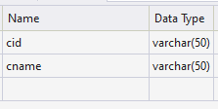

* + CART



* + HOME NEWS

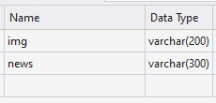

* + CLIENT DETAIL

**S.V.E.T COLLEGE JAMNAGAR | PAGE**

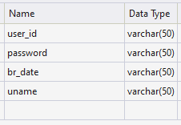

Apple Store

* SHOP DETAIL

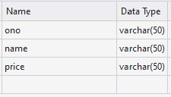

* SHOP MASTER

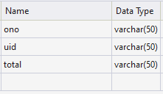

* PRODUCT

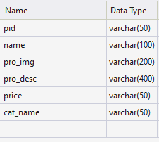

* FEEDBACK

**S.V.E.T COLLEGE JAMNAGAR | PAGE**

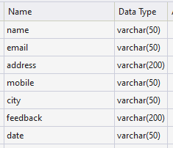

Apple Store

7 : ER DIAGRAM

ADMIN

LOGIN

CAT

ADD

CLIENT DETAIL

LOGIN

GIVE

FEEDBACK

HOME NEWS

HOME

PRODUCT

SHOP DETAIL

SHOP MASTER

**S.V.E.T COLLEGE JAMNAGAR | PAGE**

Apple Store

**8 :DATA FLOW DIAGRAM**

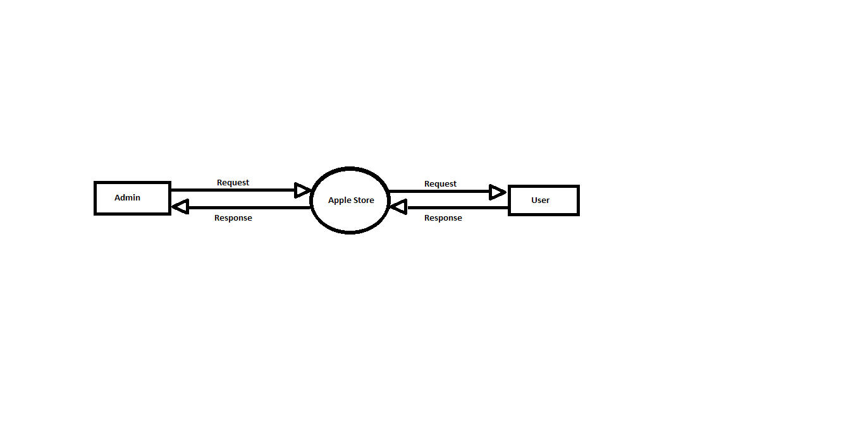

8.1 ADMIN LEVEL DIAGRAM

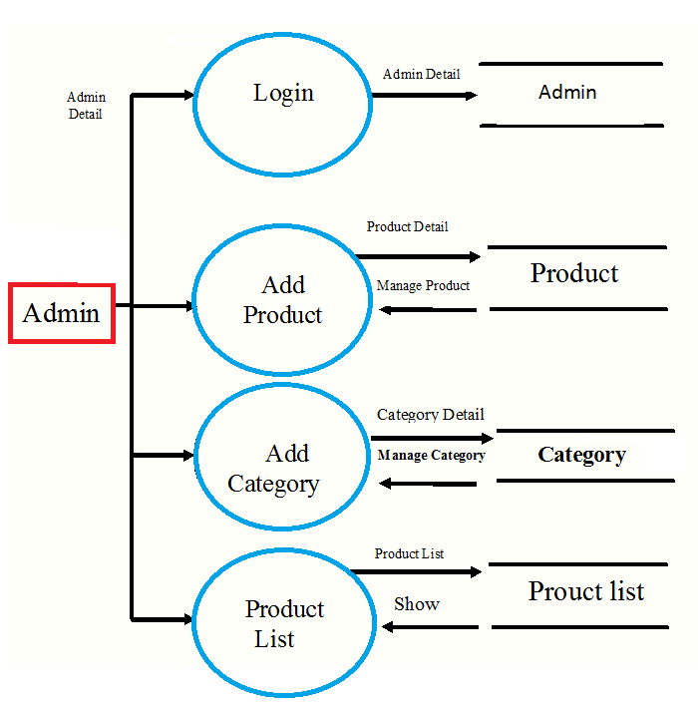

**S.V.E.T COLLEGE JAMNAGAR | PAGE**

Apple Store

8.2 USER LEVEL DIAGRAM

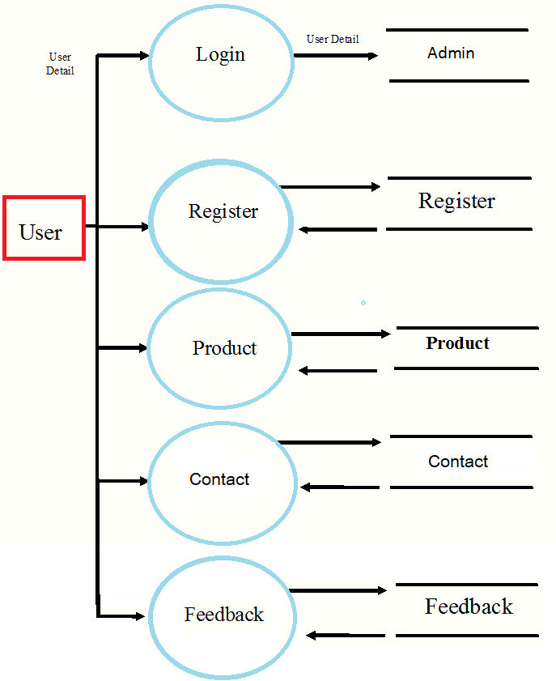

**S.V.E.T COLLEGE JAMNAGAR | PAGE**

Apple Store

**9 : TIMELINE CHART**

Apple Store

**S.V.E.T COLLEGE JAMNAGAR | PAGE**

**10 : SCREENSHOT**

* USER LOGIN PAGE

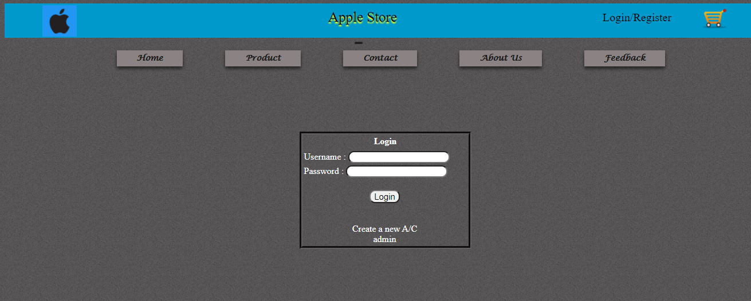

* DEFAUL PAGE

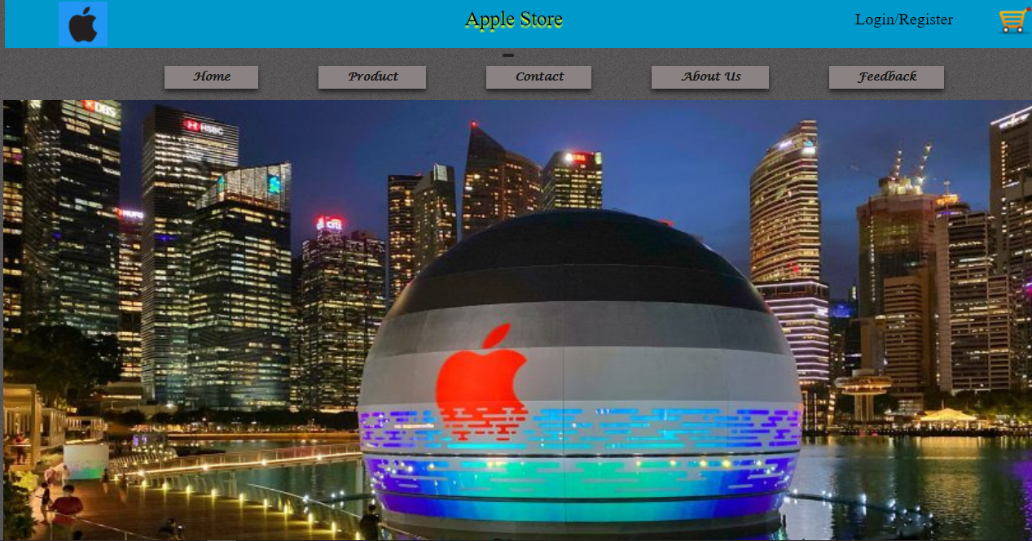

Apple Store

* USER REGISTER

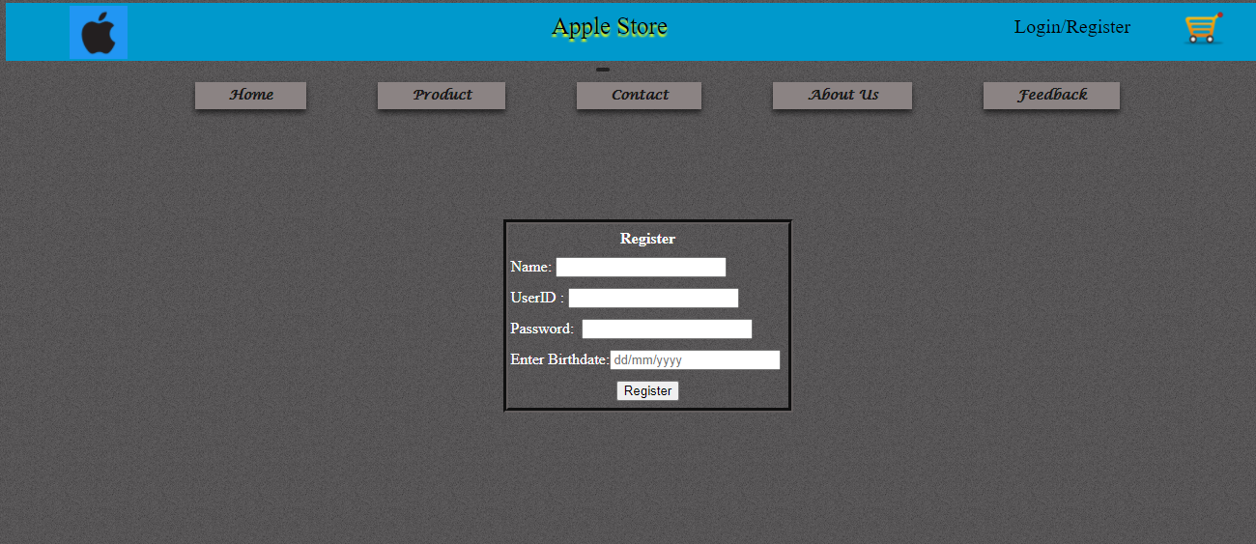

* PRODUCTS

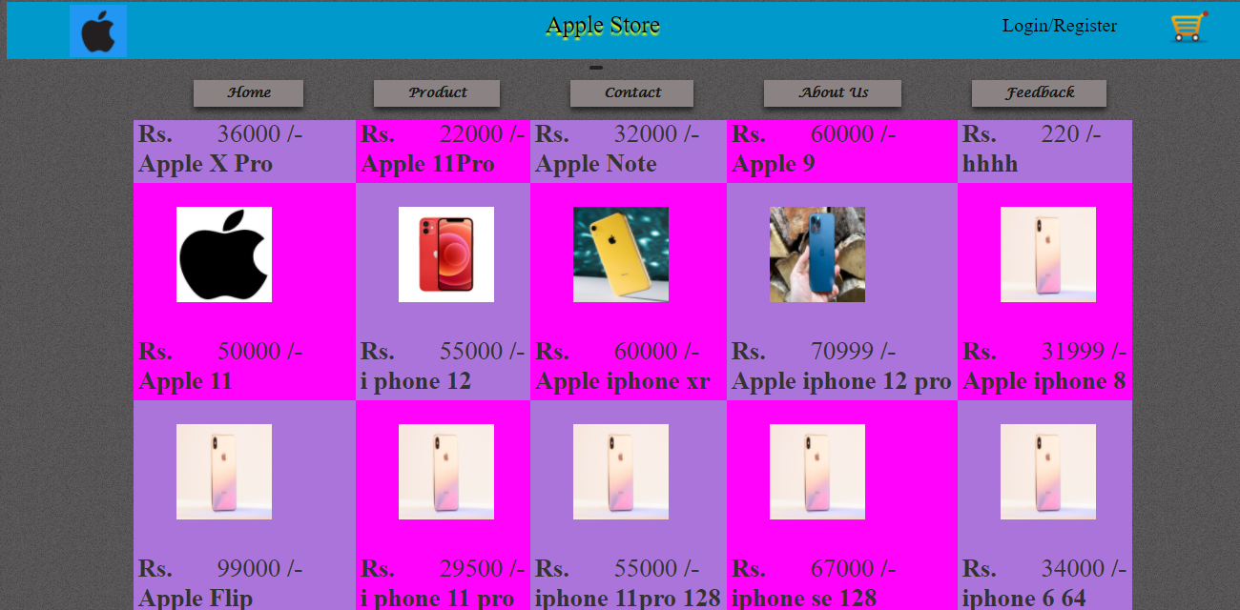

**S.V.E.T COLLEGE JAMNAGAR | PAGE**

Apple Store

**S.V.E.T COLLEGE JAMNAGAR | PAGE**

* ADD TO CART

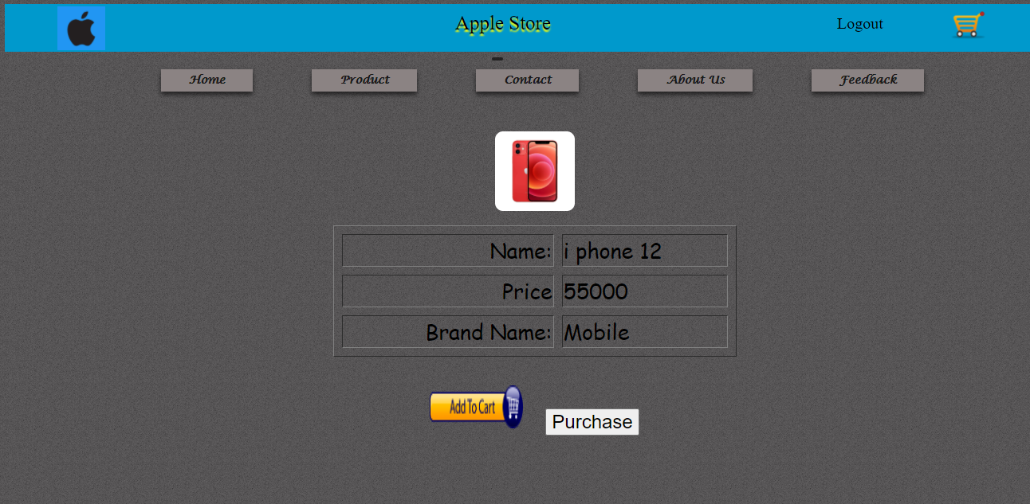

Apple Store

**S.V.E.T COLLEGE JAMNAGAR | PAGE**

**ADMIN SITE LOGIN**



**ADMIN DASHBOARD**

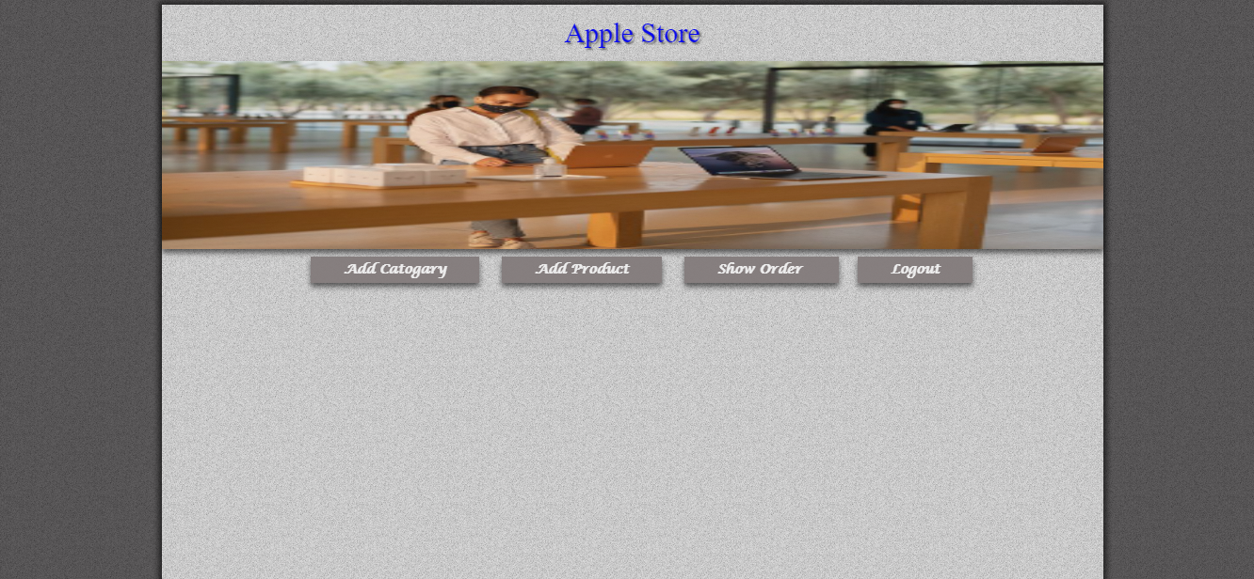

Apple Store

**S.V.E.T COLLEGE JAMNAGAR | PAGE**

**ADD_PRODUCTS**

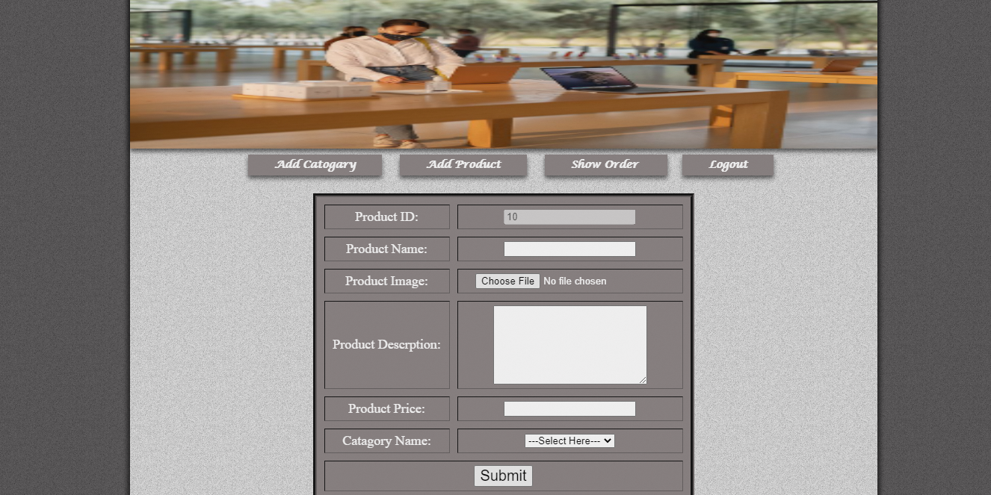

**ADD CATAGORY**

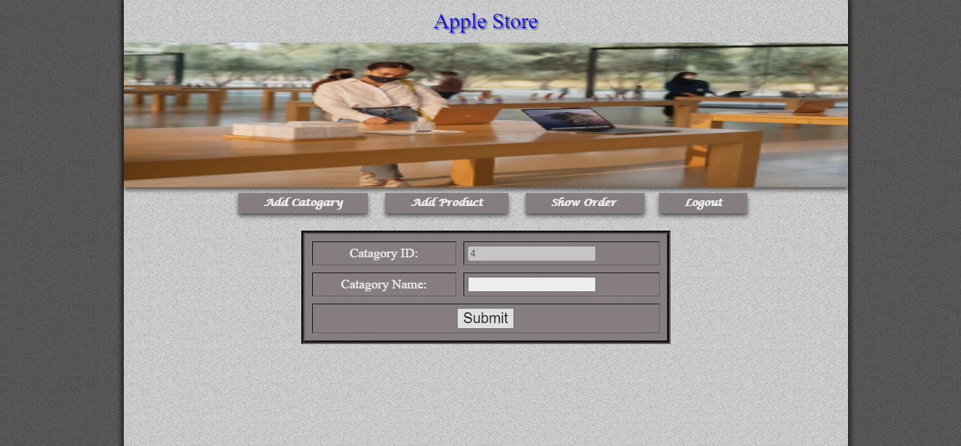

Apple Store

**S.V.E.T COLLEGE JAMNAGAR | PAGE**

* **PRODUCT LIST**

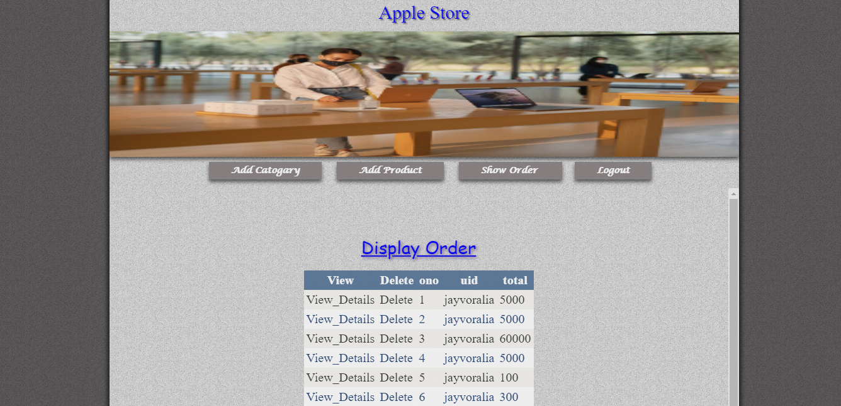

Apple store

**11 : TESTING**

**S.V.E.T COLLEGE JAMNAGAR | PAGE**

Apple store

**S.V.E.T COLLEGE JAMNAGAR | PAGE**

Apple store

**S.V.E.T COLLEGE JAMNAGAR | PAGE**

Apple store

**S.V.E.T COLLEGE JAMNAGAR | PAGE**

Apple store

**S.V.E.T COLLEGE JAMNAGAR | PAGE**

Apple store

**S.V.E.T COLLEGE JAMNAGAR | PAGE**

**S.V.E.T COLLEGE JAMNAGAR | PAGE**

Apple store

Apple store

**S.V.E.T COLLEGE JAMNAGAR | PAGE**

Apple store

**S.V.E.T COLLEGE JAMNAGAR | PAGE**

Apple store

**S.V.E.T COLLEGE JAMNAGAR | PAGE**

Apple store

**S.V.E.T COLLEGE JAMNAGAR | PAGE**

Apple store

**S.V.E.T COLLEGE JAMNAGAR | PAGE**

Apple store

**S.V.E.T COLLEGE JAMNAGAR | PAGE**

Apple store

**S.V.E.T COLLEGE JAMNAGAR | PAGE**

Apple store

**S.V.E.T COLLEGE JAMNAGAR | PAGE**

Apple store

**S.V.E.T COLLEGE JAMNAGAR | PAGE**

Apple store

**8. MAINTENANCE**

**Actively maintained**

This project has a maintainer that actively monitors its issue queue and responds in a time manner.

This means that bug reports, tasks, feature requests and support request posted in the project's

issue should receive timely attention from project's maintainers. Other community members are

also welcome to resolve issues posted to the issue queue.

**Minimally maintained**

This project has a maintainer that monitors its issue queue, but no fast response is guaranteed.

The maintainer(s) of this project may not have time to respond to all issues. However, serious bug

reports will receive attention and patches will be reviewed within reasonable delays. Maintainers

will certainly appreciate it if you read

***Helping maintainers in the issue queues***

and dive in to

help.

**S.V.E.T COLLEGE JAMNAGAR | PAGE**

Apple store

**9. LIMITATION AND FEATURES FOR FUTURE**

**LIMITATION**

Limitation is the major part of every application & system, In every Application there are always

some limitations are there. No of any application and software is without any limitation

Here I have done my try best to solve ever y limitation but some of the limitation I can’t solve

because of the level of my course, time limit, and my knowledge.

Hence my application has a some limitation are here

1.

Large Database can’t be handle.

2.

Refresh Record - After every transaction you should refresh record source.

3.

data type validation – I can’t give all proper data type & data length validation because of the time

limit

4.

Image error – here in tiles item entr y form I give a facility to store image but the limitation is that

if the image is removed f rom system of moved the error will occur.

**FUTURE ENHANCEMENT**

If you see at the first glance than you will find it to be complete but I want to make it still mature

and fully automatic. The expansion which I have thought of are:

**S.V.E.T COLLEGE JAMNAGAR | PAGE**

Apple store

**CONLUSION**

The project has been rewarding experience in more ways than one.

Initially there were problems with design and connectivity, but with the help of staff members or

other lab faculties we were able to implement them correctly

The website provides help to the customer for selecting shoes , and shopping the shoes

Secondly we have gained a highlight of how to use software engineering rules for developing a

project

An administrator can Add/product Add/categor y , , and View product list and view feedback

**S.V.E.T COLLEGE JAMNAGAR | PAGE**

Apple store

**BIBLOGRAPHY**

**Book:**

**ASP.NET(BHARAT PUB.)**

**ASP.NET BLACK BOOK**

**PROGRAMMING WITH ASP.NET**

**Web Side:**

**www.w3school.com**

**www.google.co.in**

**S.V.E.T COLLEGE JAMNAGAR | PAGE**